級別：(A卷)II-2 形容詞比較級+最高級 國 中 英 文 評 量 卷
姓名：_______________ 班級：_________ 分數： __
- 單選擇 (請選出最正確的答案；每題3分、共18%)
( ) | 1. I am 20 years old. Alice is 26 years old. I am _______ than she is.
 | (A) young | (B)younger |  | (C)youngest |  | (D)the youngest
( ) | 2. Taipei is __________ city in Taiwan.
 | (A) the largest | (B)large |  | (C)larger |  | (D)largest
( ) | 3. This is bad, but that is _________.
 | (A)badder | (B)the worst |  | (C)worse |  | (D)the worse
( ) | 4. This is ________________ problem(問題) for me.
 | (A) most important |  | (B) the most important |  | (C) more important
( ) | 5. Tommy is ________________ student in my class.
 | (A)the happier | (B)happier |  | (C)the happiest |  | (D)happiest
( ) | 6. These flowers are _____________ than those flowers.
 | (A) more beautiful |  | (B)most beautiful |  | (C)beautifuler
- 改錯 (將文法錯誤地方圈起來，圈對2分，答案對2分；每題4分、共16%)
( ) | 1 | My brother is heavyer than my sister is.
( ) | 2 | I think that she is the smart student in my class.
( ) | 3 | They are strong than we are.
( ) | 4 | This car is gooder than that car is.
- 看圖回答問題 (請用比較級或最高級作答；每題3分、共30%)
請比較以下物品價錢(作答提示: cheap, expensive)

Television
15000 NT dollars
Cell phone
6000 NT dollars
Computer
20000 NT dollars
1. The television is ________________ than the computer is.
2. The computer is ___________________________ than the cell phone is.
3. The cell phone is the ___________________.
4. The computer is the ___________________________.
請比較以下球類大小: (作答提示: big, small)
5. The baseball is ______________ than the soccer ball is.
6. The soccer ball is _______________ than the basketball is.
7. The soccer ball is the ___________.
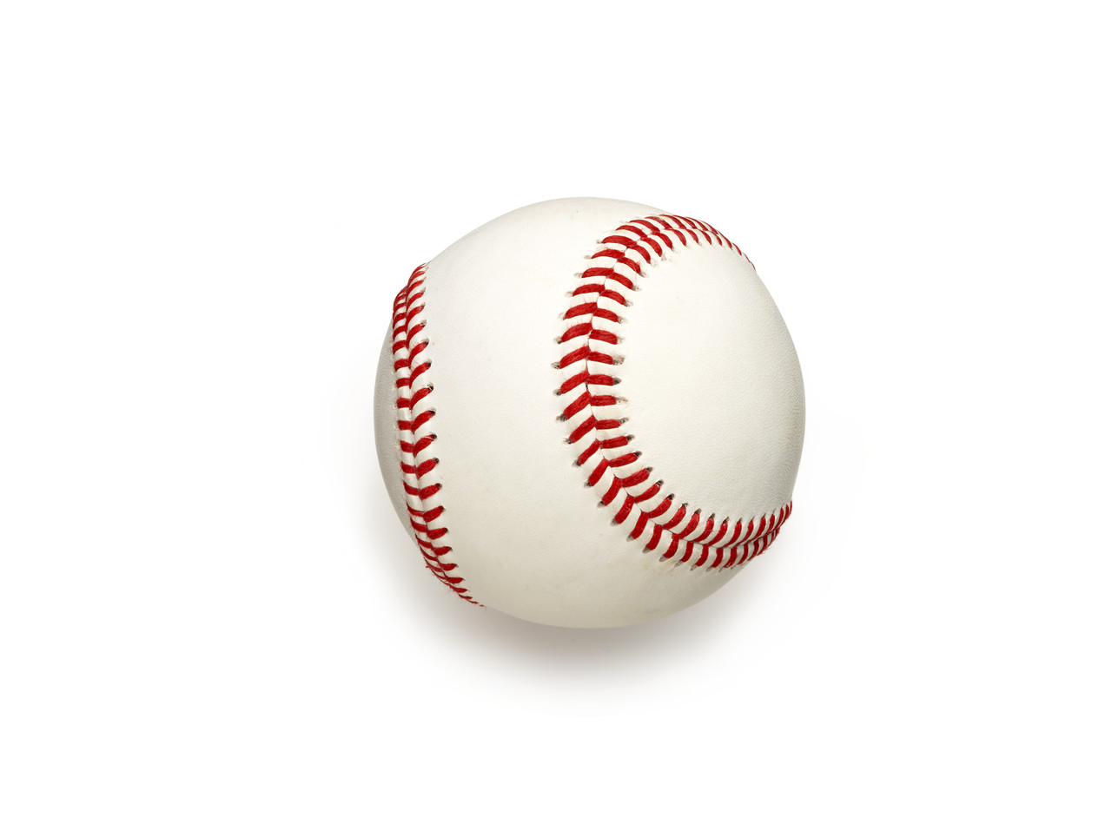
Soccer ball
Basketball
Baseball

請比較以下人物年紀(作答提示: old, young)
8. Tom is the ______________.
9. Grandmother is _____________
than grandfather is.
10. Grandfather is the __________.
Tom
15 years old
Grandfather
80 years old
Grandmother
75 years old

四、英翻中及中翻英 (每題4分、共20%)
1. | My computer is better than your computer is.
2. | This picture is the most beautiful.
3. | This novel is more interesting than that novel is.
4. | 屏東(Pingtung)比台北(Taipei)熱。
5. | 台北101(The Taipei 101)是台灣最高的大樓(building)。(提示: 高 high、在台灣 in Taiwan)

五、閱讀測驗 (請選出最正確的答案；第5題4分其餘每題3分、共16分)
Hello Samantha,
Thank you for inviting me to your birthday party last Sunday. It was interesting. I enjoyed the party and the food very much. The dishes were delicious, and I like the beef noodles most. You are really the best cook. It’s hard to find delicious Taiwanese food in the US, so I miss it very much. Could you teach me to cook beef noodles or give me the recipe?
Hope you and your family a happy weekend!
Jasmine
Tuesday, March 29th, 2020

thank 感謝/ Taiwanese臺灣的/ recipe 食譜/ hope 希望/ March 三月

( ) | 1 | When is Samantha’s birthday?
 |  | - 3/29.
 |  | - 2/29.
 |  | - 3/27.
 |  | - 2/27.
( ) | 2 | What’s the real（真的）reason（理由）for Jasmine to write Samantha?
 |  | - She wanted to say thank you to Samantha.
 |  | - She wanted to ask for the recipe of beef noodles.
 |  | - She wanted to teach Samantha how to cook beef noodles.
 |  | - She wanted to invite Samantha to her birthday party.
( ) | 3 | Which statement（敘述）is true?
 |  | - Samantha cooks very well.
 |  | - Jasmine couldn’t find beef noodles in America.
 |  | - Samantha’s birthday party was boring for Jasmine.
 |  | - Jasmine likes the Taiwanese food in the US.

( ) | 4 | How does Jasmine like the party?
 |  | - Delicious.
 |  | - Terrible.
 |  | - Boring.
 |  | - Fun.
( ) | 5 | What does Jasmine miss?
 |  | - Samantha’s party.
 |  | - Samantha’s friends.
 |  | - Taiwanese food.
 |  | - Taiwanese party.

