**級別：(A卷)II-2 形容詞比較級+最高級 國　中　英　文　評　量　卷**

**姓名：_______________　班級：_________　　　 分數： __**

1. **單選擇 (請選出最正確的答案；每題3分、共18%)**

|  |  |  |  |  |  |  |
| --- | --- | --- | --- | --- | --- | --- |
| ( ) | 1. I am 20 years old. Alice is 26 years old. I am _______ than she is. | | | | | |
|  | (A) young | (B)younger | | (C)youngest | | (D)the youngest |
| ( ) | 2. Taipei is __________ city in Taiwan. | | | | | |
|  | (A) the largest | (B)large | | (C)larger | | (D)largest |
| ( ) | 3. This is bad, but that is _________. | | | | | |
|  | (A)badder | (B)the worst | | (C)worse | | (D)the worse |
| ( ) | 4. This is ________________ problem(問題) for me. | | | | | |
|  | (A) most important | | (B) the most important | | (C) more important | |
| ( ) | 5. Tommy is ________________ student in my class. | | | | | |
|  | (A)the happier | (B)happier | | (C)the happiest | | (D)happiest |
| ( ) | 6. These flowers are _____________ than those flowers. | | | | | |
|  | (A) more beautiful | | (B)most beautiful | | (C)beautifuler | |

1. **改錯 (將文法錯誤地方圈起來，圈對2分，答案對2分；每題4分、共16%)**

|  |  |  |
| --- | --- | --- |
| ( ) | 1 | My brother is heavyer than my sister is. |
| ( ) | 2 | I think that she is the smart student in my class. |
| ( ) | 3 | They are strong than we are. |
| ( ) | 4 | This car is gooder than that car is. |

1. **看圖回答問題 (請用比較級或最高級作答；每題3分、共30%)**

**請比較以下物品價錢(作答提示: cheap, expensive)**

Television

15000 NT dollars

Cell phone

6000 NT dollars

Computer

20000 NT dollars



1. The television is ________________ than the computer is.

2. The computer is ___________________________ than the cell phone is.

3. The cell phone is the ___________________.

4. The computer is the ___________________________.

**請比較以下球類大小: (作答提示: big, small)**

5. The baseball is ______________ than the soccer ball is.

6. The soccer ball is _______________ than the basketball is.

7. The soccer ball is the ___________.

Soccer ball

Basketball

Baseball

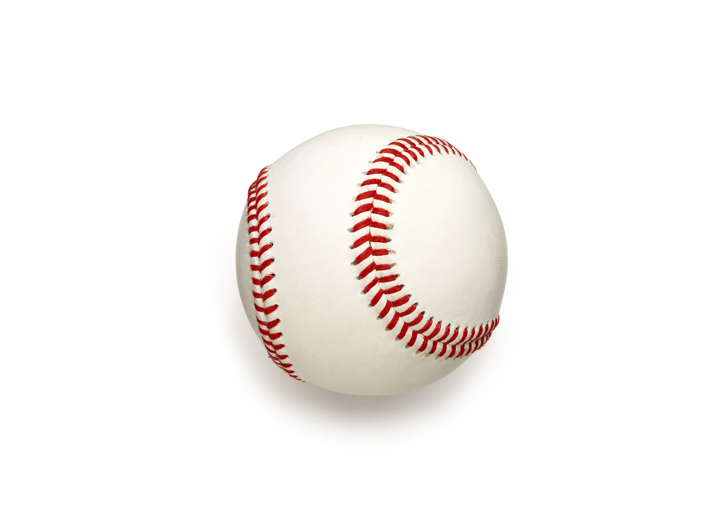

**請比較以下人物年紀(作答提示: old, young)**

8. Tom is the ______________.

9. Grandmother is _____________

than grandfather is.

10. Grandfather is the __________.



Tom

15 years old

Grandfather

80 years old

Grandmother

75 years old

**四、英翻中及中翻英 (每題4分、共20%)**

|  |  |
| --- | --- |
| 1. | My computer is better than your computer is. |
|  |  |
| 2. | This picture is the most beautiful. |
|  |  |
| 3. | This novel is more interesting than that novel is. |
|  |  |
| 4. | 屏東(Pingtung)比台北(Taipei)熱。 |
|  |  |
| 5. | 台北101(The Taipei 101)是台灣最高的大樓(building)。(提示: 高 high、在台灣 in Taiwan) |
|  |  |

**五、閱讀測驗 (請選出最正確的答案；第5題4分其餘每題3分、共16分)**

|  |
| --- |
| Hello Samantha,  Thank you for inviting me to your birthday party last Sunday. It was interesting. I enjoyed the party and the food very much. The dishes were delicious, and I like the beef noodles most. You are really the best cook. It’s hard to find delicious Taiwanese food in the US, so I miss it very much. Could you teach me to cook beef noodles or give me the recipe?  Hope you and your family a happy weekend!  Jasmine  Tuesday, March 29th, 2020 |

|  |
| --- |
| thank 感謝/ Taiwanese臺灣的/ recipe 食譜/ hope 希望/ March 三月 |

|  |  |  |
| --- | --- | --- |
| ( ) | 1 | When is Samantha’s birthday? |
|  |  | 1. 3/29. |
|  |  | 1. 2/29. |
|  |  | 1. 3/27. |
|  |  | 1. 2/27. |
| ( ) | 2 | What’s the real（真的）reason（理由）for Jasmine to write Samantha? |
|  |  | 1. She wanted to say thank you to Samantha. |
|  |  | 1. She wanted to ask for the recipe of beef noodles. |
|  |  | 1. She wanted to teach Samantha how to cook beef noodles. |
|  |  | 1. She wanted to invite Samantha to her birthday party. |
| ( ) | 3 | Which statement（敘述）is true? |
|  |  | 1. Samantha cooks very well. |
|  |  | 1. Jasmine couldn’t find beef noodles in America. |
|  |  | 1. Samantha’s birthday party was boring for Jasmine. |
|  |  | 1. Jasmine likes the Taiwanese food in the US. |

|  |  |  |
| --- | --- | --- |
| ( ) | 4 | How does Jasmine like the party? |
|  |  | 1. Delicious. |
|  |  | 1. Terrible. |
|  |  | 1. Boring. |
|  |  | 1. Fun. |
| ( ) | 5 | What does Jasmine miss? |
|  |  | 1. Samantha’s party. |
|  |  | 1. Samantha’s friends. |
|  |  | 1. Taiwanese food. |
|  |  | 1. Taiwanese party. |